Project Design Phase
Solution Architecture

Date | 2 NOVEMBER 2025
Team ID | NM2025TMID01022
Project Name | Streamlining Ticket Assignment for Effective Support System
Maximum Marks | 4 Marks

Solution Architecture:
Goals of the Architecture:
- Automate ticket assignment to reduce manual intervention
- Ensure balanced workload distribution among support agent
- Maintain transparency and traceability in the support process.
Key Components:
- Ticket Table – stores details of raised support tickets
- Agent Table / User Table – holds information about support agents
- Rule Engine / Assignment Logic – applies criteria like priority, workload, and expertise to assign tickets
Development Phases:
- Collect Ticket Data: Analyze existing ticket flow and categorize by type and priority
- 2.Define Assignment Rules: Set criteria for assigning tickets based on agent skill and workload
- 3.Monitor and Refine: Review performance analytics and adjust rules for better efficiency.
🧩 Solution Architecture Description:
The solution architecture for “Streamlining Ticket Assignment for Effective Support System” is designed to automate and optimize how tickets are distributed among support agents. The architecture uses a rule-based assignment engine that analyzes factors like ticket priority, agent expertise, and workload before automatically routing each ticket to the most suitable agent.
This system ensures fair workload distribution, faster response times, and enhanced customer satisfaction. The architecture connects the ticket database, agent profiles, and assignment logic through an integrated automation layer.
Example - Solution Architecture Diagram: 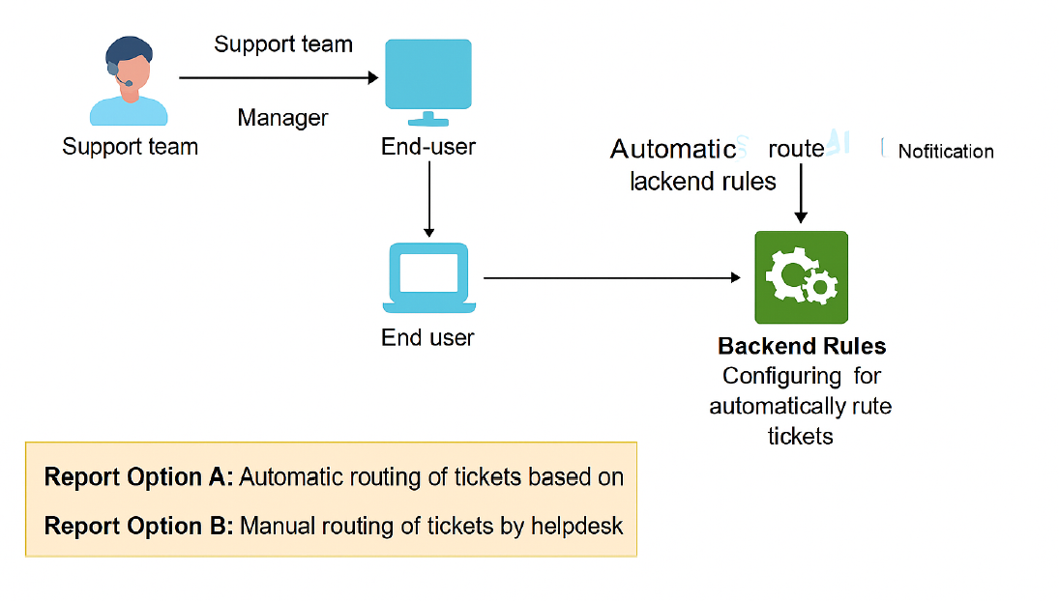Reference: https://aws.amazon.com/blogs/industries/voice-applications-in-clinical-researchpowered-by-ai-on-aws-part-1-architecture-and-design-considerations/

